# **Week 10 Homework**

**Name:** Marcus White

**Student ID:** 31455867

**Lab:** 05_OnCampus

**Tutor name:** Dr Jesmin Nahar

**Url:** [**https://mwhi0023.github.io/Data_Viz_2_Local/WEEK10HW.html**](https://mwhi0023.github.io/Data_Viz_2_Local/WEEK10HW.html)

**Screen Capture**

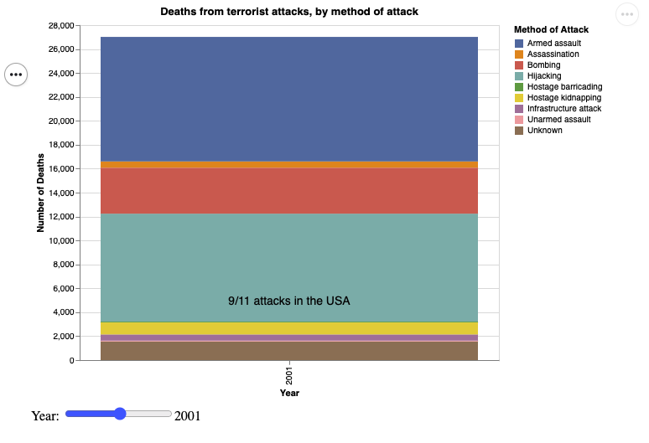

**Domain of the visualisation:** The domain of this visualisation is Global Terrorism around the world. It specifically focuses on the number of deaths related to terrorism method of attack.

**Visualised Dataset:** The visualised data set is a table sourced from the Global Terrorism Database. The author is the University of Maryland.

**Data Transformation:** The data is grouped by attack type when the original data is in event ids. This allows us to more easily understand the number of kills that occur per attack type. Many columns are also removed from the dataset as they are redundant when considering this graph.

**Justification of type of map idiom:** I chose to create a stacked bar chart as it is able easily show us the attack types which have caused more deaths from terrorism.